Practical 10:
09bce026
Implementing various classification and regression techniques using weka tool.

- Start WEKA Explorer and open any dataset from data folder in weak directory.

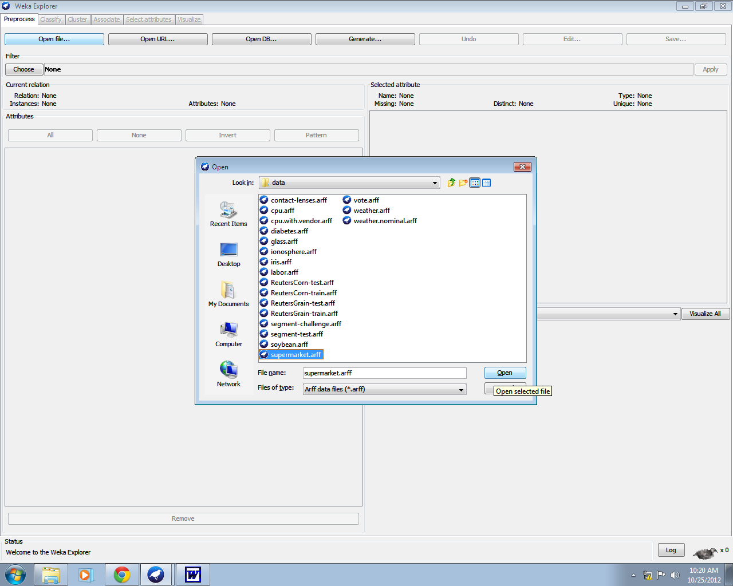

- Now go to Classify tab and choose Classifier i.e. Classification via Clustering or Classification via Regression

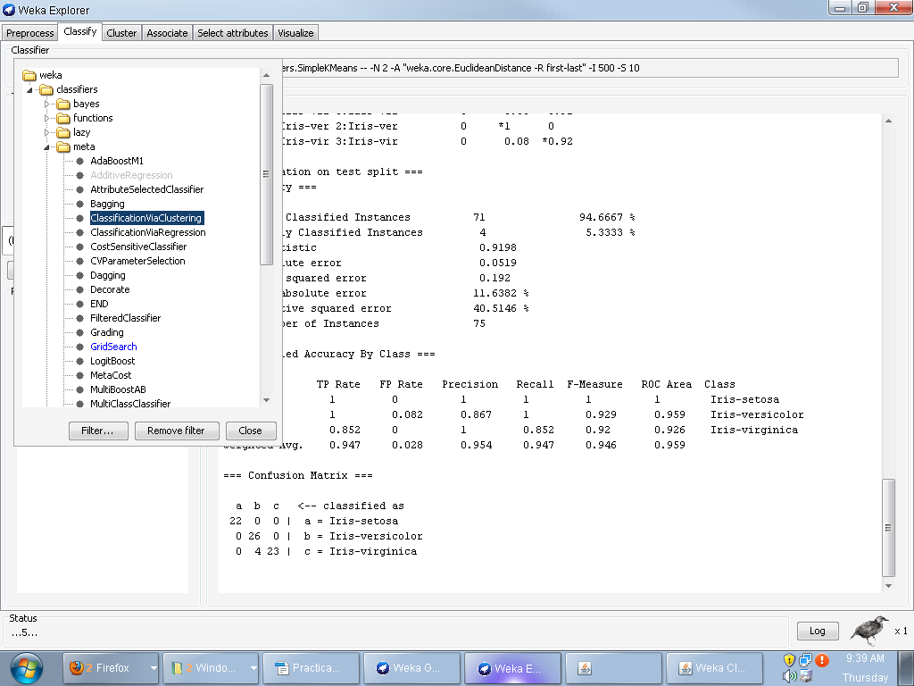
(3) In Test Options, select suitable options
->We can do Cross Validation by selection that option and giving value of folds
->We can also select split option.

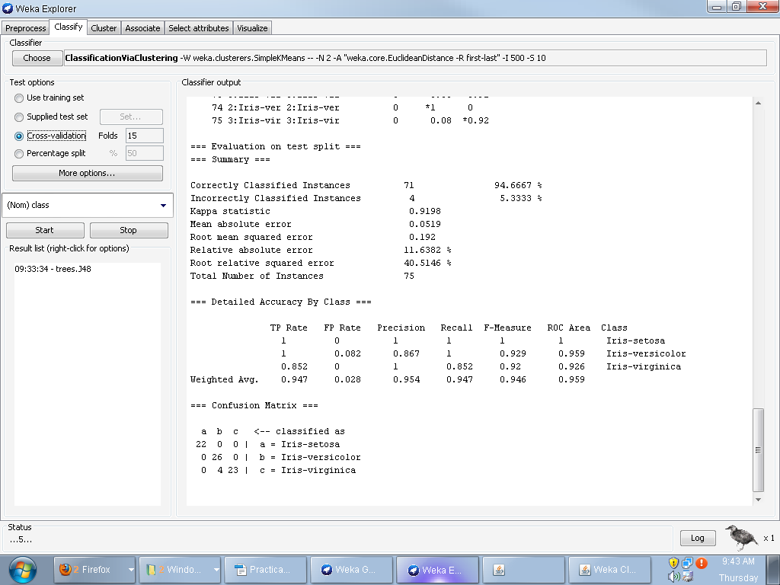
    - Click on start to see the simulation.

=== Run information ===

Scheme:weka.classifiers.trees.J48 -C 0.25 -M 2
Relation: iris
Instances:150
Attributes:5
sepallength
sepalwidth
petallength
petalwidth
class
Test mode:split 50.0% train, remainder test

=== Classifier model (full training set) ===

J48 pruned tree
------------------

petalwidth <= 0.6: Iris-setosa (50.0)
petalwidth > 0.6
| petalwidth <= 1.7
| | petallength <= 4.9: Iris-versicolor (48.0/1.0)
| | petallength > 4.9
| | | petalwidth <= 1.5: Iris-virginica (3.0)
| | | petalwidth > 1.5: Iris-versicolor (3.0/1.0)
| petalwidth > 1.7: Iris-virginica (46.0/1.0)

Number of Leaves : 5

Size of the tree : 9

Time taken to build model: 0.03seconds

=== Predictions ontest split===

inst#, actual, predicted, error, probability distribution
1 1:Iris-set 1:Iris-set *1 0 0
2 1:Iris-set 1:Iris-set *1 0 0
3 2:Iris-ver 2:Iris-ver 0 *1 0
4 1:Iris-set 1:Iris-set *1 0 0
5 1:Iris-set 1:Iris-set *1 0 0
6 1:Iris-set 1:Iris-set *1 0 0
7 3:Iris-vir 3:Iris-vir 0 0.08 *0.92
8 2:Iris-ver 2:Iris-ver 0 *1 0
9 2:Iris-ver 2:Iris-ver 0 *1 0
10 2:Iris-ver 2:Iris-ver 0 *1 0
11 3:Iris-vir 2:Iris-ver + 0 *1 0
12 3:Iris-vir 3:Iris-vir 0 0.08 *0.92
13 2:Iris-ver 2:Iris-ver 0 *1 0
14 3:Iris-vir 3:Iris-vir 0 0.08 *0.92
15 3:Iris-vir 3:Iris-vir 0 0.08 *0.92
16 1:Iris-set 1:Iris-set *1 0 0
17 3:Iris-vir 2:Iris-ver + 0 *1 0
18 3:Iris-vir 3:Iris-vir 0 0.08 *0.92
19 2:Iris-ver 2:Iris-ver 0 *1 0
20 3:Iris-vir 3:Iris-vir 0 0.08 *0.92
21 3:Iris-vir 3:Iris-vir 0 0.08 *0.92
22 3:Iris-vir 3:Iris-vir 0 0.08 *0.92
23 2:Iris-ver 2:Iris-ver 0 *1 0
24 1:Iris-set 1:Iris-set *1 0 0
25 2:Iris-ver 2:Iris-ver 0 *1 0
26 3:Iris-vir 3:Iris-vir 0 0.08 *0.92
27 2:Iris-ver 2:Iris-ver 0 *1 0
28 1:Iris-set 1:Iris-set *1 0 0
29 3:Iris-vir 3:Iris-vir 0 0.08 *0.92
30 2:Iris-ver 2:Iris-ver 0 *1 0
31 1:Iris-set 1:Iris-set *1 0 0
32 1:Iris-set 1:Iris-set *1 0 0
33 2:Iris-ver 2:Iris-ver 0 *1 0
34 3:Iris-vir 3:Iris-vir 0 0.08 *0.92
35 2:Iris-ver 2:Iris-ver 0 *1 0
36 3:Iris-vir 3:Iris-vir 0 0.08 *0.92
37 1:Iris-set 1:Iris-set *1 0 0
38 2:Iris-ver 2:Iris-ver 0 *1 0
39 2:Iris-ver 2:Iris-ver 0 *1 0
40 3:Iris-vir 2:Iris-ver + 0 *1 0
41 3:Iris-vir 3:Iris-vir 0 0.08 *0.92
42 2:Iris-ver 2:Iris-ver 0 *1 0
43 3:Iris-vir 3:Iris-vir 0 0.08 *0.92
44 3:Iris-vir 3:Iris-vir 0 0.08 *0.92
45 2:Iris-ver 2:Iris-ver 0 *1 0
46 3:Iris-vir 3:Iris-vir 0 0.08 *0.92
47 2:Iris-ver 2:Iris-ver 0 *1 0
48 2:Iris-ver 2:Iris-ver 0 *1 0
49 1:Iris-set 1:Iris-set *1 0 0
50 3:Iris-vir 3:Iris-vir 0 0.08 *0.92
51 1:Iris-set 1:Iris-set *1 0 0
52 2:Iris-ver 2:Iris-ver 0 *1 0
53 1:Iris-set 1:Iris-set *1 0 0
54 1:Iris-set 1:Iris-set *1 0 0
55 2:Iris-ver 2:Iris-ver 0 *1 0
56 3:Iris-vir 3:Iris-vir 0 0.08 *0.92
57 2:Iris-ver 2:Iris-ver 0 *1 0
58 1:Iris-set 1:Iris-set *1 0 0
59 1:Iris-set 1:Iris-set *1 0 0
60 3:Iris-vir 3:Iris-vir 0 0.08 *0.92
61 1:Iris-set 1:Iris-set *1 0 0
62 1:Iris-set 1:Iris-set *1 0 0
63 3:Iris-vir 2:Iris-ver + 0 *1 0
64 1:Iris-set 1:Iris-set *1 0 0
65 2:Iris-ver 2:Iris-ver 0 *1 0
66 1:Iris-set 1:Iris-set *1 0 0
67 3:Iris-vir 3:Iris-vir 0 0.08 *0.92
68 3:Iris-vir 3:Iris-vir 0 0.08 *0.92
69 2:Iris-ver 2:Iris-ver 0 *1 0
70 2:Iris-ver 2:Iris-ver 0 *1 0
71 2:Iris-ver 2:Iris-ver 0 *1 0
72 1:Iris-set 1:Iris-set *1 0 0
73 3:Iris-vir 3:Iris-vir 0 0.08 *0.92
74 2:Iris-ver 2:Iris-ver 0 *1 0
75 3:Iris-vir 3:Iris-vir 0 0.08 *0.92

=== Evaluation on test split ===
=== Summary ===

Correctly Classified Instances 71 94.6667 %
Incorrectly Classified Instances 4 5.3333 %
Kappa statistic 0.9198
Mean absolute error 0.0519
Root mean squared error 0.192
Relative absolute error 11.6382 %
Root relative squared error 40.5146 %
Total Number of Instances 75

=== Detailed Accuracy By Class ===

TP Rate FP Rate Precision Recall F-Measure ROC Area Class
1 0 1 1 1 1 Iris-setosa
1 0.082 0.867 1 0.929 0.959 Iris-versicolor
0.852 0 1 0.852 0.92 0.926 Iris-virginica
Weighted Avg. 0.947 0.028 0.954 0.947 0.946 0.959

=== Confusion Matrix ===

a b c <-- classified as
22 0 0 | a = Iris-setosa
0 26 0 | b = Iris-versicolor
0 4 23 | c = Iris-virginica

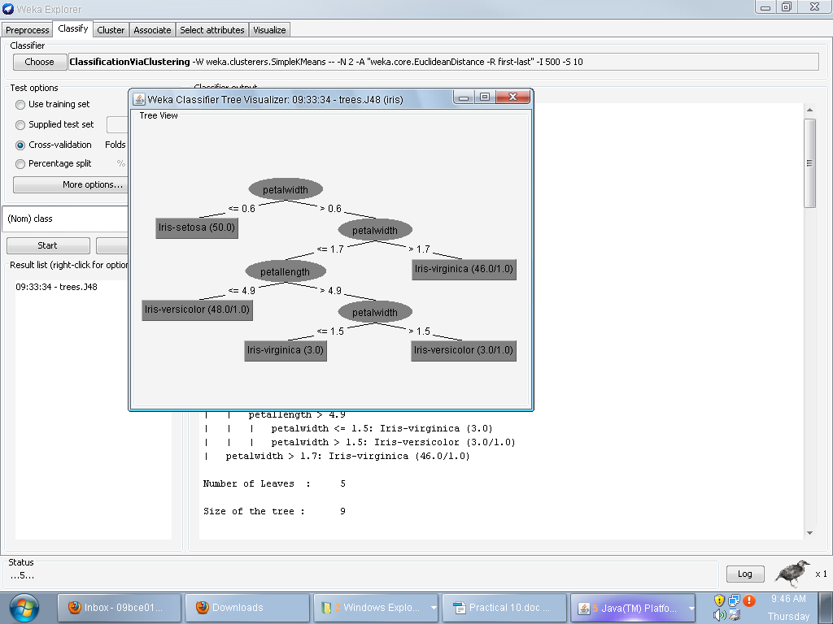
-----------------------------Classification using Decision Tree Induction----------

->Do Right-click in the Result list area and goto Visualize Tree option
->Try different datasets for simulation.

